**Automatic Disinfection Box**

User manual V.0.0.1

**Safety and General Information**

* Extreme care and precaution must be taken when using UVC lamps.
* For increased safety, do not leave the unit unattended and keep away from children.
* Humans, pets and plants should not be present inside the sanitation chamber while the UVC lamp is operating.
* Wear protective clothing when handling germicidal UV lamp. Avoid direct skin contact.
* Avoid looking directly at the lamp when it is in use.
* Do not plug and operate for more than 24 hours.
* Keep UV lamp away from direct exposure to sunlight.
* Do not store the product in hot or humid area.
* This product is non-water-resistant. Do not immerse in water or expose to moisture.
* This product is for indoor use only.

**Device Details**

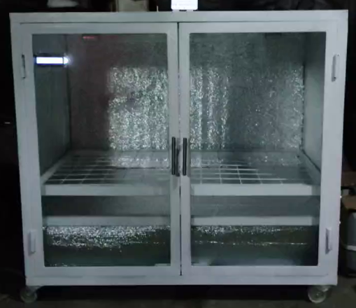

1. Automatic Disinfection Box

**Technical Specifications**

|  |  |
| --- | --- |
| Input voltage | 220v ac 50/60hz |
| Wattage | 18W |
| Rated current | 83 ma |
| UVC wavelength | 222 nm |
| Life hours | 9000 hours |
| Beam angle | 120 degrees |
| Lamp base | G13 |
| Lamp type | 18w (0.6m tube) |
| Material of the body | Steel plate cold commercial |
| Material composition of the UV lamp | Quartz lamp cap  Filament core  Mercury pill |
| Device dimension | 72 * 54 * 84 cm |

**Benefits**

1. Reduce potential risk of illness by promoting good hygiene practice and limiting your exposure to others’ germs critical for the user’s wellbeing. UV sterilization on objects effectively destroys bacteria and molds such as mites, E. coli, mucor, staphylococcus aureus etc. according to Felcostore (2022).
2. At the workplace, in the classroom, or in any space with heaps of foot traffic, germs spread rapidly, reduce transmission risk by destroying microbial growth on surfaces and inhibits from passing from one person to another. Eliminate germs occasionally for the duration of the day without leaving their study hall or work area. Eliminates harmful microorganisms from inanimate objects and surfaces such as documents, bags, parcels, etc.
3. Destroy microbial growth on microorganisms using its produce disinfection feature to disinfect. The Automatic Disinfection Box is a reusable disinfection device. This feature aids the environment by reducing plastic wastes from alcohol and sanitizer containers, the device promotes cleanliness and germicidal sanitizer prevents formation or reproduction of future causing disease.

**Product Features**

1. Disinfects, strerilizes, kills bacteria, germs and viruses such corona virus, influenza virus, anthrax, Hepa B and dysentery bacteria according to Felcostore (2022).
2. Ozone free technology.
3. Easy to operate and maintain.
4. UV lamp tube is made of ozone-free quartz glass.
5. Powder coated SPCC (commercial quality steel) body housing for excellent corrosion resistant and strength.
6. Best for home, barangays, restaurants, hospitals, hotels and even factories.

**Operation Guide**

1. Plug the AC connector behind the automatic disinfection box to power outlets with stable electricity.

**Usage and Maintenance**

1. To maximize performance, make sure to clean it occasionally.
2. Do not put the device in an unstable, flammable and wet area. This is for indoor use only.
3. Avoid exposing the product to heavy fumes or smoke.
4. Do not immerse in water or any other liquid. This is a non-water-resistant product.
5. Do not alter or modify the unit, the researchers will not be responsible for any personal injury because of device misuse.

6. Do not use the product other than its intended purpose.

7. Call a qualified technician in case servicing is needed.

**Attention when Cleaning**

1. Make sure to unplug the unit from the power supply before cleaning.
2. Use a soft and damp cloth when cleaning the device
3. Do not use excessive water or abrasive material during cleaning.
4. Do not use chemicals and detergents to avoid device discoloration.
5. Do not attempt to open any part of the device when cleaning.

**Correct Disposal of the Device**

Do not dispose with other household items to prevent possible harmful effect on environment or human health. The researchers encourage to recycle it responsibly or return the device to the researchers.

**Contact info**

John Christopher B. Bagas

Charles Adriane S. Guerrero

Marcus M. Saralde

Email: [mmsaralde.pro@gmail.com](mailto:mmsaralde.pro@gmail.com) | [leesharped@gmail.com](mailto:leesharped@gmail.com)

Contact number: 0933 654 2264